CS2800 4/4/2011

PROJECT – Lights Out!

Lights Out! is a 1-player game consisting of a game-board that is in the form of a 4 x 4 grid of bulbs connected by wires as shown below. A move of the player consists of clicking on some bulb. Clicking on a bulb will toggle the state of the clicked bulb and also any bulb directly connected to the clicked bulb. To toggle the state of a bulb means to turn it on if it is initially off and vice versa. The objective of the player is to turn all the lights out (off) starting from an initial configuration.

In HW11 you built up the graphics skills needed to execute this project. The project is in two phases. You will deliver Phase I at the end of Week 1, (due 4/9/2011) and Phase II at the end of Week 2 (due 4/16/2011). There are two Extra Credit extensions (the first is worth 200 pts and the second is worth 200 pts). You have until 4/20/2011 to submit the Extra Credit sections.

Phase I (100 pts, due 4/9/2011)

Create a 4 x 4 Lights Out! game-board as shown below (as in HW11 your code should be parameterized by a general n which is defined to be the constant 4 up-front). Add two buttons to the board – a CONFIGURE/FREEZE button and a HELP button. The board is initially in the “configure” state during which time the button reads FREEZE. In this state the player will have the option to add/remove wires and set each individual bulb’s state. Once satisfied with the configuration, the player should toggle the button to freeze the configuration and move into the “play” state. In the “play” state the caption on the button should display CONFIGURE. Toggling the CONFIGURE button any time during “play” state should bring the board back to the last frozen configuration and put it back in “configure” state .

During Phase I of the Project the HELP button is non-functional, its functionality will be developed in Phase II. The “play” state is the regular state where the player moves by toggling a bulb (and its neighbors). This version of the problem is more general than the usual Lights Out! allowing the user to create different game boards (by deleting an arbitrary set of wires from the full game-board grid) and setting arbitrary initial states. See below for an example of an initial configuration that can be created by removing wires. The game-board arrives at its desired final state when the player turns all the lights out (off). At this point flash the message “SUCCESS” for 3 seconds and restart a fresh game in the initial configuration.

Hint: Keep track of the state of the game-board using a bit-vector of length 16 with a 1 representing the “on” state and a “0” representing the “off” state.

a) Give an example of an initial game-board from which it is not possible to reach the final state, i.e. turn all lights out. Such a game-board is said to be unsolvable.

Formalize and prove the following two theorems in ACL2:

b) Repeating a move twice is equivalent to not playing the move at all.

c) The state of the game-board is a function only of the set of moves played and not the order in which they were played.

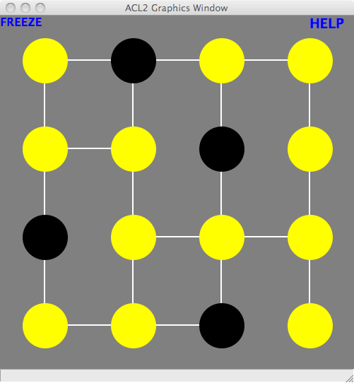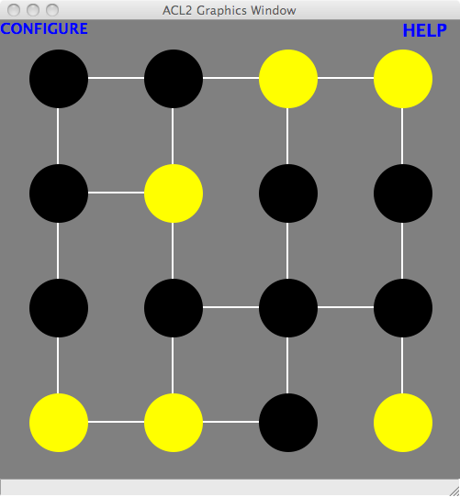
“Configure” state Configuration done and in “play” state

Phase II (100 pts, due 4/16/2011)

In this phase, add functionality to the “HELP” button as follows. During “configure” state, the HELP button should have no effect on the board. Remember from Phase I that it is not always possible to reach the final state (all lights out) from a given initial game-board. If the game-board is unsolvable then at any point (non-final state) in the game when the HELP button is pressed flash UNSOLVABLE for 3 seconds and restart. If the game-board is solvable then, at any point (non-final state) in the game when the HELP button is pressed, automatically play a move (i.e. toggle a bulb and its neighbors) that will take the game-board one move closer to the final state. Flash this toggled bulb for 3 seconds to communicate to the player exactly which move was played. Hitting the HELP button repeatedly should take the game-board all the way to the final state (with the flashing SUCCESS and then the restart).

Express the solvability of the initial game-board as a propositional expression (PropExp) and use the SAT-SOLVER developed in HW4 to determine the solution. This is the “code” behind the HELP button. There are no theorems to prove for Phase II beyond the usual contract needed for ACL2s to admit your solution.

Hint 1: Extend the syntax of PropExp from HW4 to cover the parity operator. This will substantially shorten the length of your expressions.

Hint 2: Rather than use the SAT-SOLVER each time the HELP button is pressed figure out a way to use it once at the beginning and recover all subsequent solution moves from the initial solution.

Extra Credit I (200 pts, due 4/20/2011)

Observe that if we went from a 4 x 4 board to a 100 x 100 board then a SAT-SOLVER would not terminate in any reasonable time (try it).
a) Using a SAT-SOLVER, what is the largest board for which you are able to determine solvability in under 5s?
Instead of expressing the solvability of the board as a propositional expression, express it as a set of linear equations (using addition mod 2, the technical term for this is GF2). Replace the SAT-SOLVER by a solver for a system of linear equations (SLE-SOLVER). Show that you can quickly determine solvability of a 100 x 100 board.
b) Using an SLE-SOLVER what is the largest board for which you are able to determine solvability in under 5s?

Hint: Solve the linear equations using Gaussian elimination.

Extra Credit II (200 pts, due 4/20/2011)

a) Prove or disprove the following conjecture (with or without ACL2s): any game-board that has all the light bulbs turned on is solvable.

In Extra Credit I, you saw how the use of an SLE-SOLVER (as compared to a SAT-SOLVER) dramatically sped up things (testimony to the power of algorithmic thinking). But there is more! When a game-board is unsolvable then all a SAT-SOLVER can present as evidence of the unsolvability is a detailed record of all its exertions – it tried all possibilities and failed. However when an SLE-SOLVER fails to solve a system of linear equations it can produce a very succinct witness that the system is indeed unsolvable. This motivates the following:
b) Prove that if a game-board is unsolvable then there exists a subset S of the bulbs so that no matter which of the bulbs is toggled there will always be an odd number of bulbs in S that are turned on. (Observe that this is direct proof of the unsolvability of the game-board). Augment your SLE-SOLVER from Extra Credit I to find this S.

